1. **Storage Units Page Content:-**

All the pages **header** and **footer** section I have already described in **Home page content Doc File**.

**List of pages follow the same way as one page**:-

1. storage-units
2. personal-storage
3. business-storage
4. containers

When we open pages from the admin, that time **edit page** and **edit with visual composer** option is appear at the top of the page.

**Click on these option**, we can edit the content of these pages. These are the 2 ways, we can use.

Please see on the screenshot:-

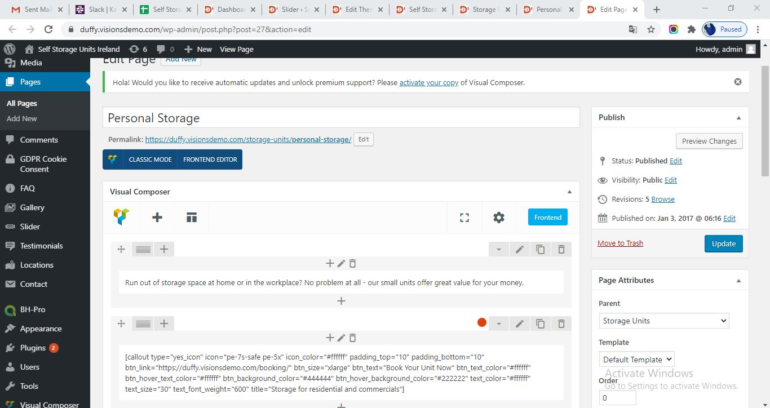

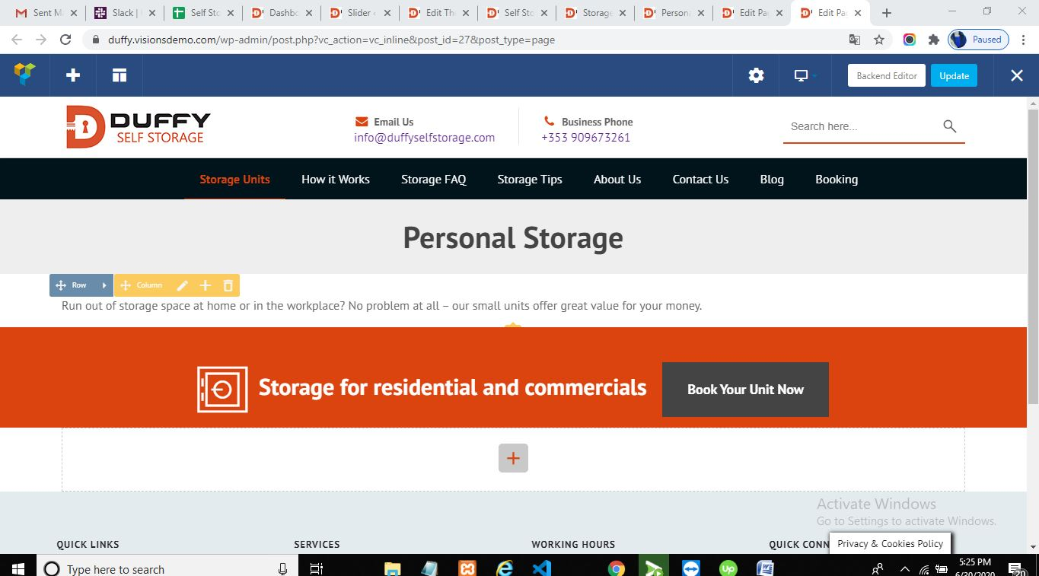

On these screenshots, when we hover the content, edit option will be appear above the content, from where we can edit the contents and after that save the contents and final **upload** the page changes.

1. **About Us and How it works Pages Contents:-**

Same for these pages, we need to open page from admin, and click on **edit page /edit with visual composer** option present at the top of the page.

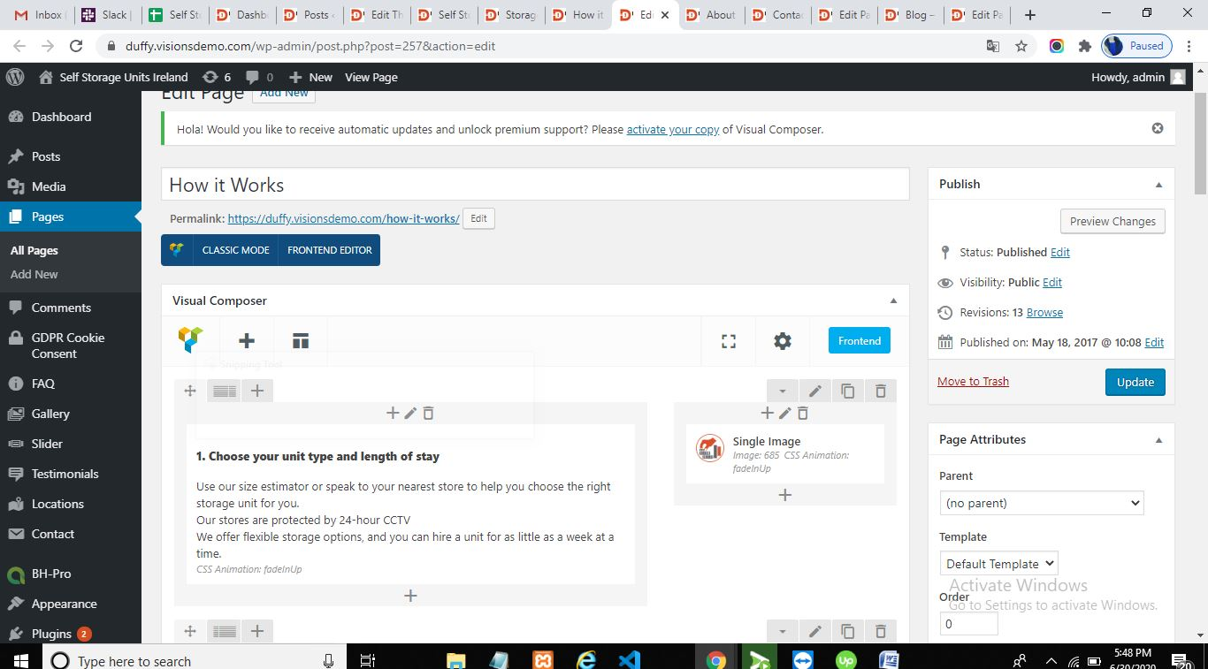

1. **Contact Us Page Content Change:-**

All the section of contact us pages are also edit form **edit page** option as the same.

One thing is different, the field of contact form we can change follow the path:-

Go to **Admin dashboard**-**click on Contact Field:** see the following **screenshot:-**

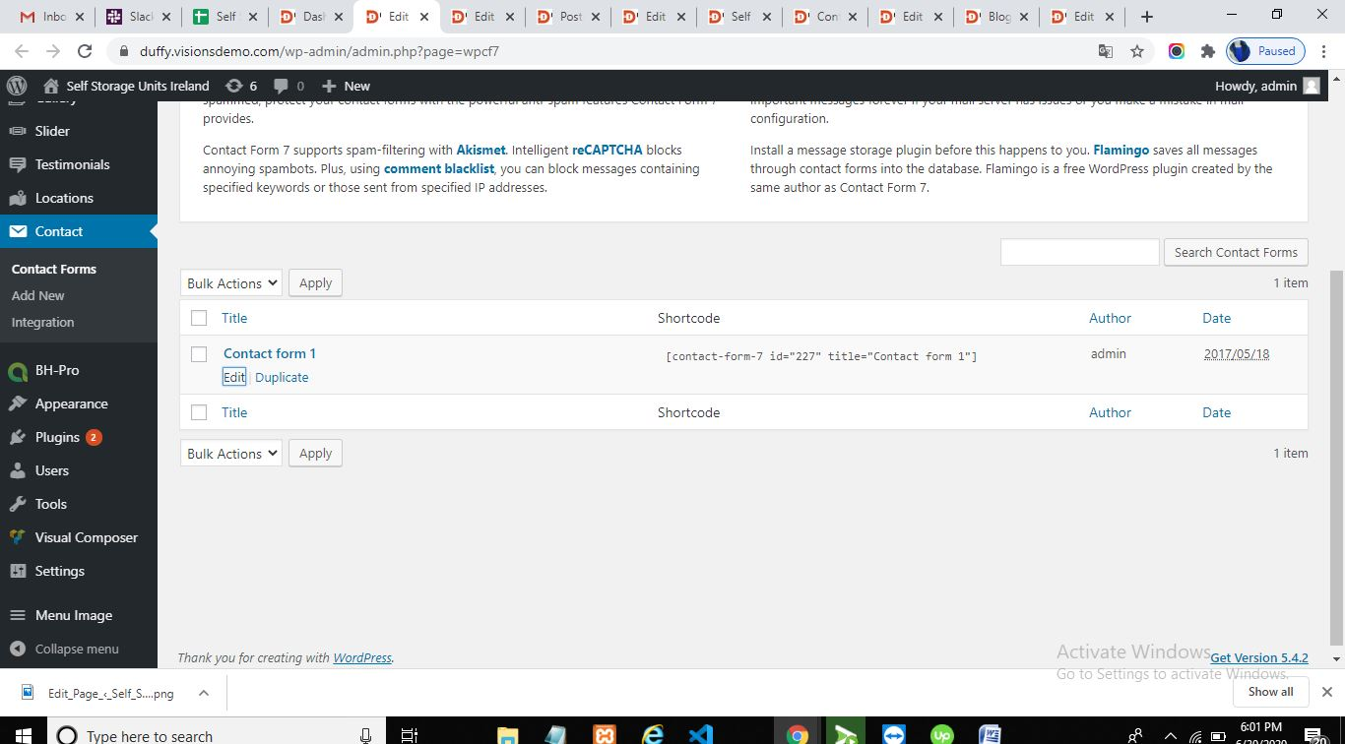

Then click on **Edit option** as we can see below on the **Contact form 1** , here we can change the fields of form as per our requirement and click on save button.

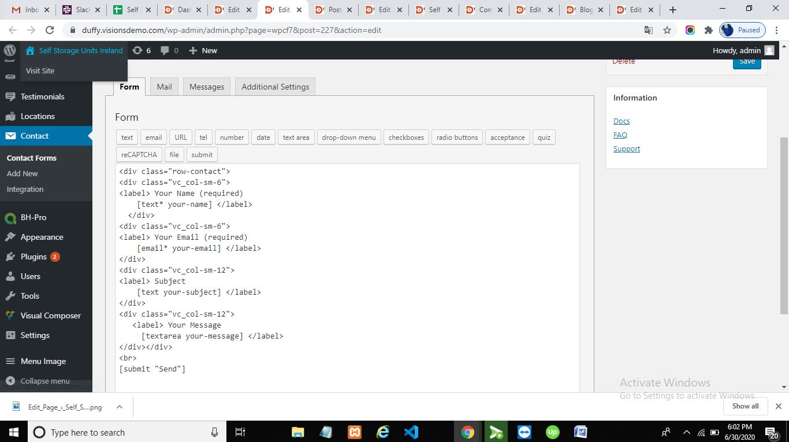

1. **Blog Page contents : (Posts):-**

All the posts we can edit and change form the following path:-

Go to **Admin dashboard**-**click on All Posts:** see the following **screenshot:-**

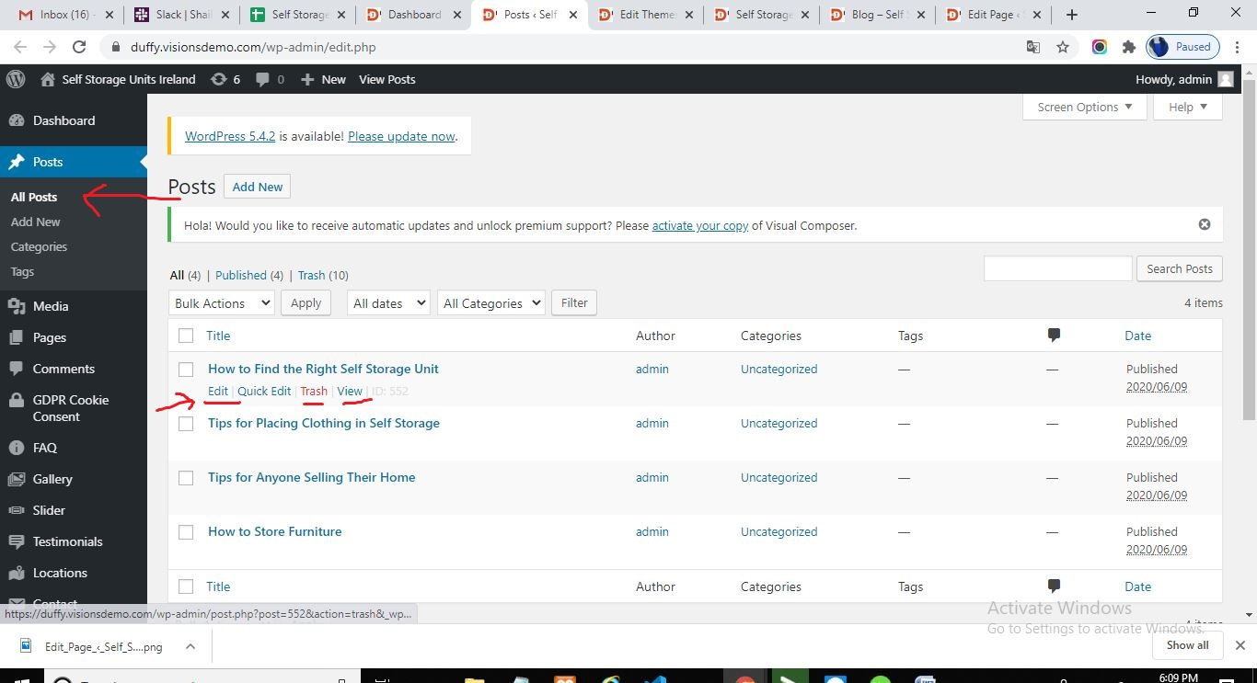

In the above images, we can see all **the posts**, can **add new** post : click on **Add post** and edit the post by clicking on **Edit** option.

After clicking on Edit option, see the following image:-

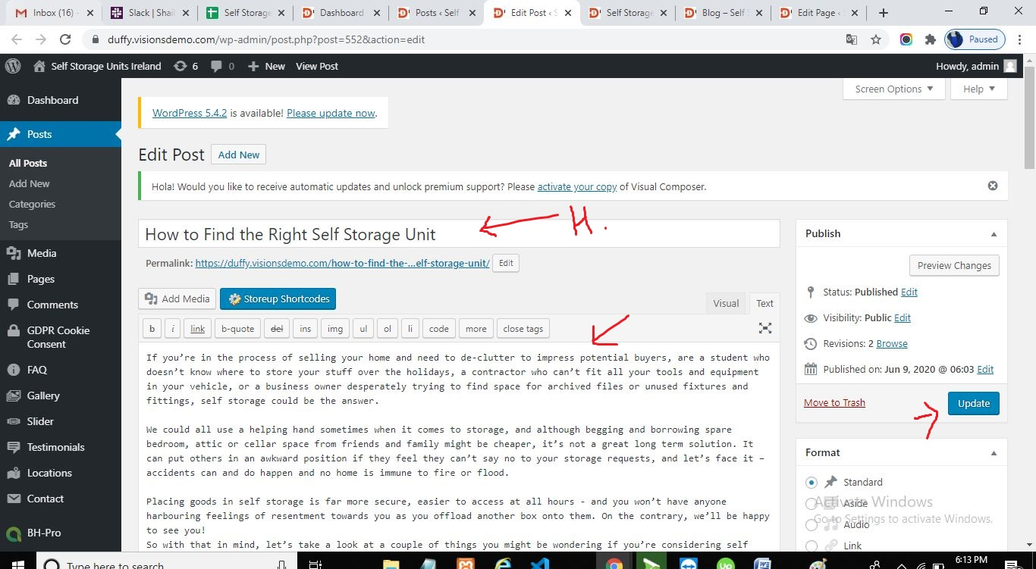

Add heading at the top as we can see on image and other content in text field, also the **featured images** option is there to select the image we want to add and then click on **update button** for saving the changes.

1. **Storage FAQ and Storage Tips Pages content:-**

All the contents, we can changes using the same method click on **edit page** option.

Here are the changes, all the questions and tips can we change using the following path:-

Go to **Admin dashboard**-click on **FAQ:** see the following **screenshot:-**

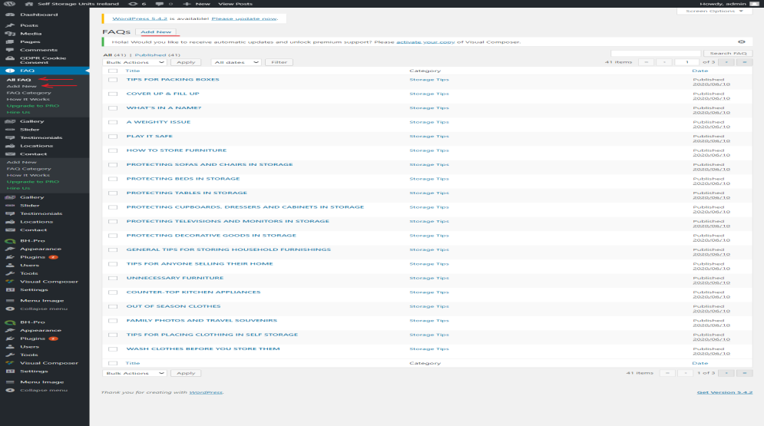

In the above screenshot, we can add the **new** **Storage Tips** and **Storage FAQ**.

We can edit the tips or question, while we hover these above fields the **edit option** is appear there. See below:

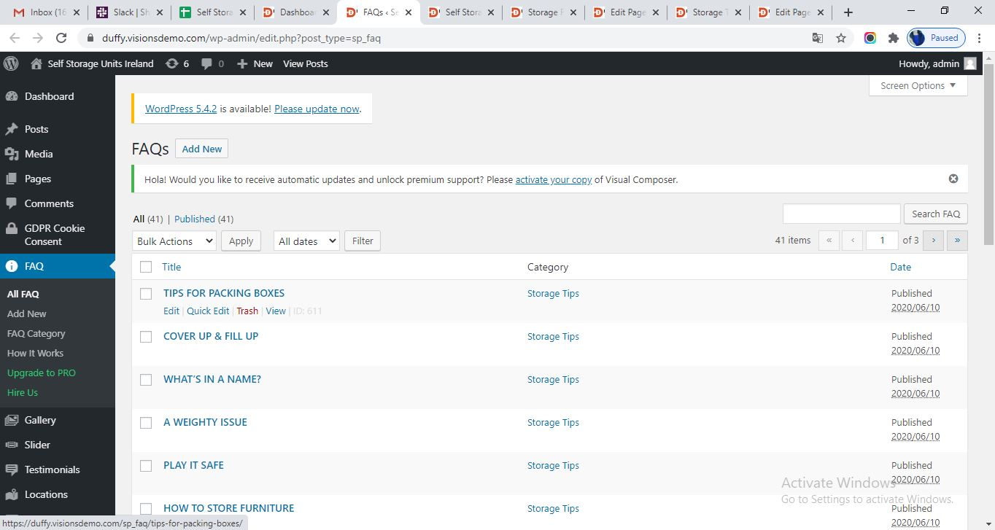

Click on **edit option** following page will appear:-

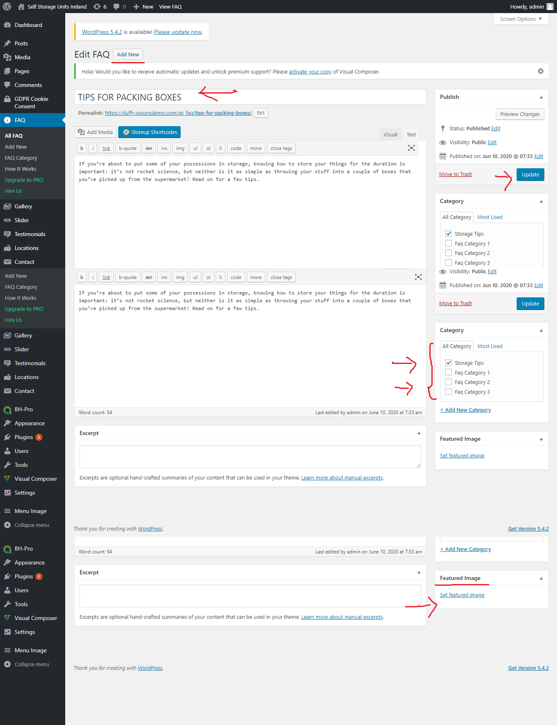

In above page, we can add new by clicking on **Add New** and can change heading and contents and can set **featured image** if we need.

Differentiate the post by clicking on **category**. In the category, if we want to add Storage Tips then select **Storage Tips** category and if we want to add **FQA** the select the category accordingly.

All the changes we can need to do carefully .